Sample Options

Minimum 50 Person Order Please

Stationary Display:
With 7 of the following $23.95* per person + 22.9% service fee
With 8 of the following $25.45* per person + 22.9% service fee
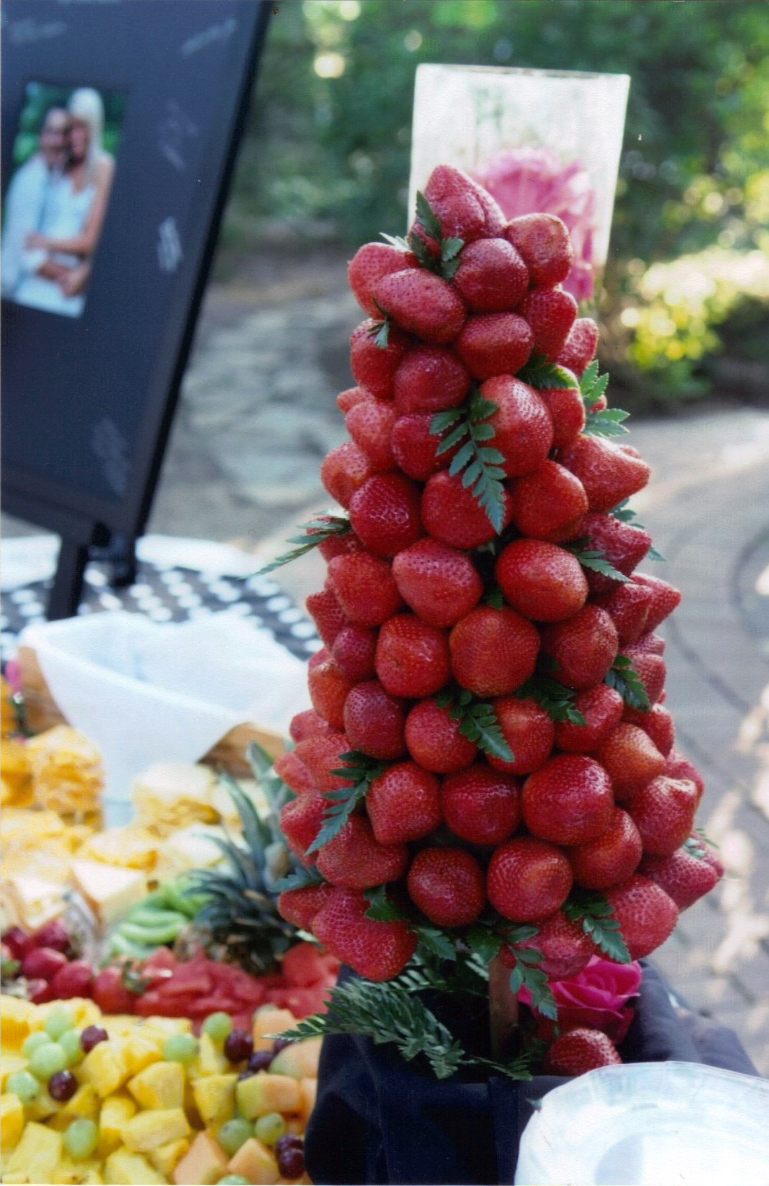
With 9 of the following $27.95* per person + 22.9% service fee
*estimate price, final price determined with menu selection

~International Cheese Display with assorted dips, artesian meats, and fruit garnish
~Praline Bacon Strips
~Shrimp Cocktail on Mini Martini Glasses
~Coconut Crusted Shrimp Lollipops w/Pineapple Chili
~Braised Beef Crostini with Balsamic Onion Jam
~Boursin Cheese, Pesto and Spinach Stuffed Mushrooms
~Mini Corn & Crab Cakes with Chili Aioli
~Adobo Beef Quesadillas with Pico
~Mini Beef Wellingtons
~Asian Chicken Salad on Wonton Crisp
~Tomato Bisque Soup Shooters with Gouda Grilled Cheese
~Warm Raspberry Almond Brie En Croute with Crackers
~Grilled Salmon Skewers with Raspberry Glaze
~Pecan Crusted Chicken &Waffles with Maple Shooter Stix
~Asparagus Wrapped with Goat Cheese and Phyllo
~Red and Yellow Tomato Bruschetta with Balsamic Reduction
Our success is derived from balancing tradition and innovation. Our food is a combination of the familiar and the new – always seeking new ideas that will satisfy the client and keep it fresh, while remembering our culinary roots and the classic techniques underlying all great cooking.

Like theatrical performers, we seek ways to bring the thrill of opening night to every event.

~Tuscan (Spinach & Cheese) Chicken Flatbread Pizzettes
~Sesame Crusted Ahi Tuna on Wonton with Wasabi Mayo
~Goat Cheese Macadamia Nut Crusted Chicken Bites
~Twice Baked Red Skin Potatoes
~Apple, Mushroom, Onion and Gruyere Tarts
~Pear and Brie Quesadillas with Mango Peach Salsa
~Salad Martini’s (favorite salad in a martini glass)
~Chef Carved Beef Tenderloin with yeast rolls, caramelized onions, sautéed mushrooms and horseradish cream (Add $1.25pp)
Don’t forget to add your Sweet Treats
~Chocolate Covered Cheesecake
~Buckeye Spoons
~Mini Crème Brulee on Chinese spoons
~Mini Fruit Tarts with lemon chiffon crème.
Elite Catering
937-559-4590

www.elitecatering.com
contact@elitecatering.com

Clear plastic disposable included with real flatware.
~Add china on the buffet instead for $2.85 per person

Service is 22.9%* of final invoice

